Client Skype setup
Install Skype for on iOS
- From your phone, click the to go to the App Store and search for Skype.
- Tap Get >Install.
Once you’ve installed follow the next set of directions:
- On the Sign in screen, tap Create account.
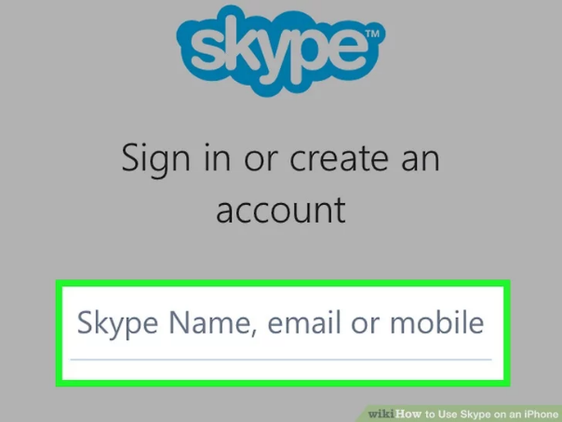
- You will be prompted to create a new account using your phone number.
Note: You may get a message that an account already exists, if there is an account associated with that phone number. You can sign into Skype with that existing account, but you will not be able to create a new one. If prompted please go to account.live.com to reset password via the phone
- Enter your phone number and tap Next.
- Enter your first and last name and tap Next.
- You will be sent a one-time password to your phone.
- Enter your one-time password to sign in and start enjoying Skype.

Install Skype for Business on Android
- From your phone, click the to go to the Google Play Store, and search for Skype.
- Tap Install. Once you’ve installed follow the next set of directions:
- Tap accept when prompted to. Doing so will allow Skype to start downloading.
- On the Sign in screen, tap Create account.

- You will be prompted to create a new account using your phone number.
Note: You may get a message that an account already exists, if there is an account associated with that phone number. You can sign in to Skype with that existing account but you will not be able to create a new one. If prompted please go to account.live.com to reset password via the phone.
- Enter your phone number and tap Next.
- Enter your first and last name and tap Next.
- You will be sent a one-time password to your phone.
- Enter your one-time password to sign in and start enjoying Skype.

